REffect of the COVID-19 pandemic on the risk on the the Croatian capital market

Marija Ivanković  
*Department of mathematics and economics*  
 *Zagreb School of Economics and Management*Zagreb, Croatia  
[mivankov1@student.zsem.hr](mailto:mivankov1@student.zsem.hr)

*Abstract*—This research is concentrated on the risk on the Croatian capital market and how was it affected by the COVID-19 pandemic. The project consists of theoretical and practical parts. The theoretical part deals with questions like what is risk, how do we classify it, and how do we measure it? The practical part consists of stock price analysis, beta coefficient calculations, correlation analysis and forecasting.

Keywords—risk, COVID-19 pandemic, stock prices, Croatian capital market.

# Introduction

For years, research will be conducted on how the COVID-19 pandemic has affected the world economy. Humanity has encountered various pandemics before (Spanish flu, plague, AIDS), but no other pandemic has had such a global impact. The levels at which we are trying to measure today are probably unprecedented since the plague (which wiped out almost a third of the population). This pandemic is not much different from the others in terms of illness and prevention, but the economic consequences have been unprecedented.

The pandemic came suddenly and has affected almost every sphere of our way of life so far. The new coronavirus, officially named SARS-CoV-2, which causes the new infectious disease COVID-19 (Coronavirus infectious disease 2019), conquered the whole world from December 2019 to May 2020, causing a pandemic in which more than 4.7 million people became ill and 316,000 died by mid-May 2020. [1]. The consequences of its spread are still being added up today. The virus first emerged in China and eventually in the rest of the world. The main conclusion of the extensive epidemiological analysis of the Chinese Centers for Disease Control (CCDC) on 72,314 cases of COVID-19, from December 30 to February 11, 2020, was that the virus is highly contagious and has spread throughout China in 30 days, strict prevention measures. "[2]. Due to the emergence of the new COVID-19 virus, most world authorities, with rare exceptions, have decided, in order to prevent the further spread of the virus, to close the economy. They imposed a so-called lockdown and several other preventative measures. You probably remember the slogan "Stay home" from the beginning of the pandemic. The phrase still evokes various and robust feelings today. Not only was there a closure of shops, and offices, but in a way, there was a closure of people. Socialization was kept to an absolute minimum to prevent further spread of the virus and tragic outcomes.

Lockdown, i.e. complete closure and stoppage of the economy and activities, is not something unseen so far. What is unseen is the level at which the lockdown took place. Almost the entire world went into lockdown in March 2020, causing massive disruptions to the existing economic system that was not ready for it. As a result of measures, uncertainty and market speculation, the economic crisis that followed s one of the biggest since the Great Depression. The lack of general information certainly did not help. Apart from knowing almost nothing about the characteristics of the disease we encountered, we also did not know how the measures taken to prevent infection with that same disease would affect the economy. The growth of uncertainty in the market, which due to this lack of information, funding and increased speculation, has led to extreme changes, especially in the capital market.

*Research problem*

This brings us to the very subject of research in this paper. The main question is how the emergence of the COVID-19 virus and its pandemic affected capital market risk. Specifically on the Croatian capital market. Risk is a well-known thing to each of us. The official definition of risk is the probability of an event occurring that usually has a negative impact on us. Risk in the capital market is a similar thing; only the consequences can sometimes be not negative but catastrophic (more on risk later).

As already mentioned, the subject of the research is the impact of the pandemic on risk in the Croatian capital market. For the purposes of the study, prices of 10 shares from the CROBEX10 index are used as a representative sample (with equal weights of 10% for an arbitrary portfolio).

A portfolio is a collection of financial investments like stocks, bonds, commodities, cash, and cash equivalents, including [closed-end funds](https://www.investopedia.com/terms/c/closed-endinvestment.asp) and [exchange-traded](https://www.investopedia.com/terms/e/etf.asp) (ETFs).  A portfolio may contain a wide range of [assets](https://www.investopedia.com/terms/a/asset.asp), including real estate, art, and private investments.[3]

The first sample was taken from 2019, and the second from 2021. The sample consists of the closing stock prices in the portfolio, which we will use to calculate their returns. And using the established link between return and risk, calculate the risk.

Beta as a measure of systematic risk will be discussed in detail in Chapter 3. What you need to know for now is that a higher beta indicates a higher systemic risk. This means that if we get that the beta was once lower than the beta in the period after that, we will be able to conclude that there was an increase in systemic risk and vice versa.

*Research hypothesis*

The main hypothesis of the paper is that the risk on the Croatian capital market has increased under the influence of the COVID-19 pandemic. As an alternative hypothesis, it has been put forward that the risk has stayed the same or decreased under the influence of the pandemic.

The expectations for results are that the risk has increased. The reasoning behind it is that various uncertainties and economic crises that occurred due to the pandemic led to a subsequential increase in the Croatian capital market.

As a measure of risk (in this case systematic), we took the beta coefficient (which we will explain later). As it was said, in principle, a higher beta coefficient means a higher risk. We will compare the portfolio’s beta and individual components on the beta of CROBEX10 and the general CROBEX index from 2021 to 2019. If the beta coefficient for the 2021 sample is higher than the beta coefficient for 2019, we can conclude that the risk has increased. The reverse is true if the beta for 2021 is less than the beta coefficient for 2019. Depending on the results of the research, we will draw a conclusion on whether the outbreak of the coronavirus pandemic affected the risk on the Croatian capital market.

# Theory behind the risk

As I have already stated, the risk is the probability of an event happening. But how can we translate that into terms that we are using in this research? Since we are dealing with financial instruments, we are using financial notions of risk and financial ways of quantifying it. In broad terms, financial risk is the possibility of losing money on an investment or business venture [4]. There are many types of financial risks. The ones this paper is concentrating on area-specific and especially systematic risk.

The specific risk applies only to a particular company, industry, or sector [4]. It is called specific because it is associated with just one stock or industry and doesn't have an effect on the rest of the economy (hence specific). Other terms that are commonly used are unsystematic risk or diversifiable risk [4]. The difference between specific and systematic risk is that the specific risk can be managed using diversification, which is a risk management strategy that mixes a wide variety of investments within a portfolio [5]. What this means is that a portfolio manager, when arranging a portfolio, uses a mix of assets from different industries, companies or sectors. They do this because every industry, company or sector has its specific risk which is preferably not correlated to the other industry (this will be later discussed in the correlation analysis part). By minimalising this type of risk they expect to get higher returns.

On the other hand, systematic risk refers to the risk inherent to the entire market or a market segment. It is also known as undiversifiable risk or market risk [4]. The reasoning behind the terms is as follows. For „undiversifiable“ risk, I have already stated, that we can't minimize it by adding assets from different sectors of the economy. For the term „market“ it means that it affects the overall market, not just a particular stock or an industry [4].

*Risk and return*

In order to quantify the risk, we have to have some numbers. Since we are dealing with financial risk, we are using financial assets. More specifically, their returns, which are derived from their prices. The reason we use returns is because there is a direct relationship between risk and return that will be assessed later.

Return is defined as the percentage return on the investment [6]. It is calculated as follows:

$$r=\frac{P\left(t+1\right)-Pt+Div}{Pt}$$

$$r-return$$

$$P\left(t+1\right)-price at time t+1$$

$$P\left(t\right)-price at time t$$

$$Div-dividend$$

It can also be defined as the sum of the dividend yield and percentage capital gain [6].

$$Dividend yield=\frac{Div}{Pt}$$

$$Percentage capital gain=\frac{P\left(t+1\right)-Pt}{Pt}$$

In order to define the relationship between risk and return, we should first define the expected return, which is the mathematical expectation of the return of the asset or portfolio.

Risk on an asset depends on the dispersion or spread of possible outcomes [6]. When estimating the spread of possible outcomes from investing in the stock market, most financial analysts start by assuming that the spread of returns in the past is a reasonable indication of what could happen in the future. Therefore, they calculate the standard deviation of past returns [7]. We can take a whole population of returns or a sample, and calculate the population or sample variance or standard deviation.

- variance

$σ$-standard deviation

r- return

E(r)-expected return

N-number of observations

The expected return is calculated as the sum of a product of a return and the probability of occurrence of that return. In some special cases, it can be calculated as a mean value (when the probability of occurrence is equal for every return).

$$E\left(r\right)=Σr*p$$

$E\left(r\right)$-expected return

- return

$p$-probability of occurrence of return r

This is all true when we talk about a specific asset, but when we are talking about a portfolio or a set of assets. Firstly, to calculate the risk, we need to calculate the expected return of the portfolio. The expected return of the portfolio is the weighted average of the expected returns of each asset in the portfolio. The weights are the share of the specific asset in the whole portfolio [6].

$$E\left(rp\right)=Σwi E(ri)$$

$E\left(rp\right)$– expected return of the portfolio

$wi$-weight of the specific asset

E($ri)$- expected return of a particular asset

Since specific risk can be diversified, investors who have diversified portfolios are only concerned about macroeconomic and other fluctuations that affect the systematic risk. The fluctuations in question can be changes in interest rate, government spending, oil prices, foreign exchange rate, an economic recession or in our case a global health crisis in the shape of a pandemic. So, how do we measure and mitigate that systemic risk?

Firstly, let's say we have a hypothetical portfolio. How do we know if it is a good one? What is our benchmark to determine that? The benchmark against which we measure it is called a market portfolio. A market portfolio is a portfolio of all assets in the economy. In practice, a broad stock market index is used to represent the market [6]. A market portfolio, in an ideal setting, should contain all assets on the market to effectively display the changes in the assets like bonds, securities, real estate, etc. In practice that is not attainable, so analysts usually use a market portfolio that will represent a specific market segment. For example, later in the research part, I will compare my arbitrary portfolio of 10 Croatian companies against the Croatian stock index CROBEX, which will serve as a market portfolio for that specific market segment (I will also use another measure, but more on that later). Another index that is commonly used is the S&P500 index, not just because of the large number of assets in the index, but also because of its performance.

So now that we have our benchmark, it is time to measure the risk of an individual asset or a portfolio against it. The sensitivity of stock returns to fluctuations in the returns of the market portfolio is measured by the beta coefficient, the star of this research. It is annotated by the greek letter β.

The beta coefficient of a given asset is equal to the covariance between the returns of the asset and the returns of the market portfolio, divided by the variance of the returns of the market portfolio [7].

$$β=\frac{cov\left(r,rM\right)}{σ^{2}M}$$

$β$-beta coefficient

$cov\left(r,rM\right)$-covariance between the returns of the asset and the returns of the market portfolio

$σ^{2}M$-variance of the market portfolio

The beta of a porfolio is calculated as the weighted average of the betas of the assets that are included in the portfolio. [6]

$$β=Σwi*βi$$

Interpreting the beta coefficient is very important. On its own, the higher the beta coefficient the higher the sensitivity of a stock to market movements, meaning we classify it as a riskier asset or another term that is used is „aggressive stocks“. Usually, their beta is higher than 1,0. The polar opposite of that is a defensive stock, characterised by a lower beta coefficient, meaning it is less sensitive to market fluctuations, its beta being lower than 1,0. The average beta of all stocks is exactly 1,0 [6].

In the CAPM, systematic risk, measured by *β* will be linked to the expected return E(r) and hence to the pricing of individual securities and portfolios. CAPM stands for Capital Asset Pricing Model, and it is an important model in finance because it gives us a direct link between risk and return. Higher the systematic risk, the higher the return required by investors as a premium for exposure to this kind of risk.

Financial theory today, with the help of the CAPM explains the connection between returns and risk based on the fact that risk is relevant when investing in stocks, systemic risk because diversification does not reduce it. CAPM links return and the systemic risk of the stock and determines the amount of the minimum acceptable return. [6]

In mathematical terms it is expressed like:

$$E\left(r\right)=rf+β\left(rm-rf\right)$$

$E\left(r\right)$-expected return

$rf$-risk-free rate

$β$-beta coefficient

$rm$-market rate

In this case, we can interpret the beta coefficient as the slope because it represents the change in the return which is caused by the change of the market premium (difference between market rate and risk-free rate). This will be very important later because it gives us a way of calculating the beta coefficient using linear regression.

In conclusion, expected rates of return demanded by investors depend on two things: compensation for the time value of money (the risk-free rate) and the risk premium that depends on the beta and the market risk premium [6]. This is very important for investors because they are not interested in standard deviation as a measure of risk. They are interested in how adding one new stock to the portfolio affects the overall risk of the portfolio, and the measure that shows that is the beta coefficient.

# research

*General approach*

To do the research we would use two samples of data. Common to these samples will be their components. The samples will actually be based on an arbitrary portfolio that will be a reflection of the Croatian stock exchange index CROBEX10. The portfolio would consist of 10 shares that 1. They must be a member of CROBEX10; 2. They must be liquid; 3. Due to the need to diversify the portfolio, it is desirable that they be from different industries. List of shares is given below:

|  |  |
| --- | --- |
| ADPL | AD Plastik d.d. |
| ADRS2 | ADRIS GRUPA d.d. |
| ARNT | Arena Hospitality Group d.d. |
| ATGR | ATLANTIC GRUPA d.d. |
| ATPL | ATLANTSKA PLOVIDBA d.d. |
| ERNT | ERICSSON NIKOLA TESLA d.d. |
| HT | HT d.d. |
| KOEI | KONČAR d.d. |
| PODR | PODRAVKA d.d. |
| RIVP | Valamar Riviera d.d. |

Table 1. Portfolio of stocks

The samples differ in the time from which we will take them. The first sample will contain stock prices before the pandemic, and the second stock prices after the start of the pandemic. I will be using the two time series. First from 21.02.2019. to 21.02.2020 (time before the pandemic) and the second from 24.02.2020. to 24.02.2021 (time after the pandemic).

The portfolio is meant to represent the Croatian Capital Market (aka Zagreb stock exchange or ZSE). In order to determine whether the risk has changed or not, we need a benchmark. In this case, the benchmarks will be the prices and returns of the Croatian stock index CROBEX, CROBEX 10 index, as a representative of the risk-free market portfolio or asset.

*Data*

The data is downloaded directly from the ZSE website, which contains all the historical prices of the stocks and indices. The data is downloaded as a CSV file that is then imported into python notebook in which we are doing the analysis.

Since the stock market doesn’t work on certain days like weekends and holidays, there is going to be some missing data, and that can clearly be seen on the graph below. The disruptions in the data flow are visible as streaks.

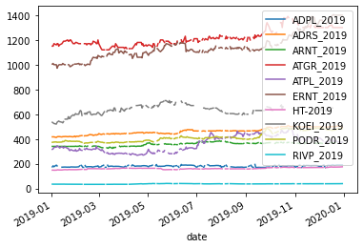

Fig 1. Stock prices for 2019 (before filling the data)

This problem was solved by interpolating data using interpolate function in python. In the mathematical field of numerical analysis, interpolation is a type of estimation, a method of constructing (finding) new data points based on the range of a discrete set of known data points [8]. In summary, it is used to estimate unknown data between two known data points. After interpolating, our data set is continuous without missing values.

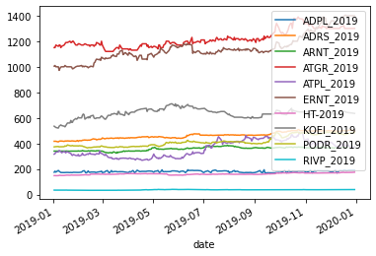Fig 2. Stock prices in 2019 (after interpolating)

The same was done to stock prices for 2021, CROBEX prices and CROBEX 10 prices.

*Data analysis*

After resolving the issue of missing data, I did some standard data analysis for the stock prices. Some of which was calculating the returns (which will be vital in later research) and caluclating the standard deviation.

The returns are calculated using the percentage change funcion pct_change(), which automatically gives us returns as percentages.

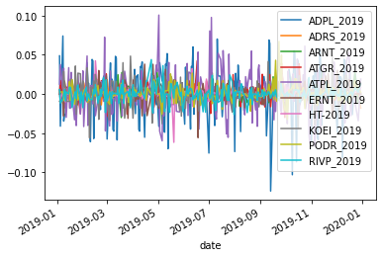

Fig 3. Returns for stock prices from 2019

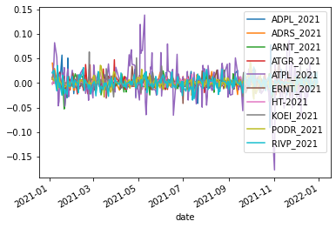

Fig 4. Returns for stock prices from 2019

As for standard deviation, it was calculated using the std() function that automatically gives us the standard deviation for each stock in our portfolio.

|  |  |
| --- | --- |
| ADPL_2019 | 0.028401 |
| ADRS_2019 | 0.005917 |
| ARNT_2019 | 0.007862 |
| ATGR_2019 | 0.010788 |
| ATPL_2019 | 0.025514 |
| ERNT_2019 | 0.010683 |
| HT-2019 | 0.007119 |
| KOEI_2019 | 0.013376 |
| PODR_2019 | 0.010027 |
| RIVP_2019 | 0.009412 |

Table 2. The standard deviation of stocks for 2019

|  |  |
| --- | --- |
| ADPL_2021 | 0.013959 |
| ADRS_2021 | 0.009156 |
| ARNT_2021 | 0.010136 |
| ATGR_2021 | 0.010246 |
| ATPL_2021 | 0.032458 |
| ERNT_2021 | 0.009185 |
| HT-2021 | 0.005712 |
| KOEI_2021 | 0.010603 |
| PODR_2021 | 0.009451 |
| RIVP_2021 | 0.011923 |

Table 3. The standard deviation of stocks for 2021

As I already mentioned, assessing risk as a spread of values using standard deviation is one of the ways of quantifying risk in financial terms. This leads us to our first comparison of risk before the pandemic and after the pandemic. If we calculate the weighted average standard deviation for our portfolio for both time periods and compare them, we can see if a change in risk happened, which may be as a result of this pandemic (weights of each stock in the portfolio are as stated 10%). The standard deviation of the portfolio is calculated using the covariance matrix and portfolio weights.

$$σ=\sqrt{w^{T}*Cov*w}$$

$w^{T}$-transposed weights

$Cov$-covariance matrix

- weights

Standard deviation 2019= 0,00002841

Standard deviation 2021=0,00003555

As we can see there has been a slight decrease in volatility between these two time periods. But this is unfortunately not enough to reject or not to reject our hypothesis. The reason is that standard deviation by itself is not a sufficient measure of risk, because it doesn’t take into account the systematic risk.

*Beta coefficient calculation*

This leads us to our next stop in the risk analysis journey. The calculation of the beta coefficient. As previously stated benchmarks or market portfolios against which we will calculate beta are CROBEX index prices, CROBEX10 index prices. But since the beta coefficient deals with returns, we need to calculate the returns of these market portfolios. Same as with prices of stocks, there were some missing data, which was supplemented with the interpolation method, same as with the prices od stocks.

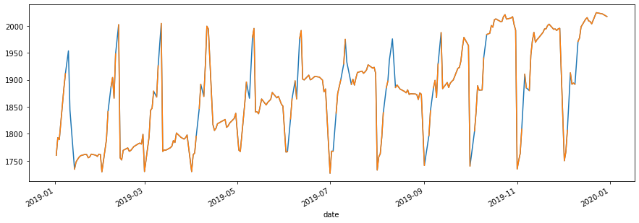

Fig 5. Returns of the CROBEX index for 2019 (after interpolation)

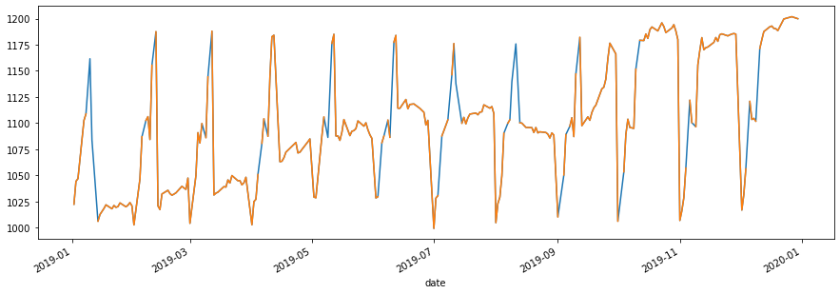

Fig 6. Returns of the CROBEX 10 index for 2019 (after interpolation)

The blue lines on the graph indicate the data that was supplemented with the interpolation method.

Now that our data is sorted out, we begin with calculation. Using the Linearregression() model from scikitlearn, we state our target and features (dependent and independent values). Our features were the returns of stock and our target value was the return of the indices. After performing the linear regression it should give as an output as a vector with ten components, each of the components being the beta coefficienf ot an individual stock in the portfolio. As the measurement of perforance the model, we take mean squared error (MSE).

The beta coefficients between return of stocks and market portfolios for 2019 are as follows:

|  |  |
| --- | --- |
| ADPL | 0,486 |
| ADRS2 | 0,201 |
| ARNT | 0,004 |
| ATGR | 0,110 |
| ATPL | 0,040 |
| ERNT | -0,045 |
| HT | -0,064 |
| KOEI | -0,047 |
| PODR | 0,064 |
| RIVP | 0,030 |

Table 4. Beta coefficients between the stocks in the portfollio and CROBEX index for 2019

|  |  |
| --- | --- |
| ADPL | 0,553 |
| ADRS2 | 0,306 |
| ARNT | 0,040 |
| ATGR | 0,092 |
| ATPL | 0,028 |
| ERNT | -0,035 |
| HT | -0,078 |
| KOEI | 0,103 |
| PODR | 0,109 |
| RIVP | 0,057 |

Table 5. Beta coefficients between the stocks in the portfolio and the CROBEX10 index for 2019

As previously defined, the beta of a portfolio is calculated as the weighted average of the betas of the assets that are included in the portfolio.

$$β=Σwi*βi$$

The weight for every stock in the portfolio is 10%, and when we calculate the beta for these cases we get:

CROBEX beta 2019=0,088

CROBEX10 beta 2019=0,118

The process is repeated for the year 2021.

The beta coefficients between the return of stocks and market portfolios for 2021 are as follows:

|  |  |
| --- | --- |
| ADPL | 0,126 |
| ADRS2 | 0,083 |
| ARNT | 0,062 |
| ATGR | -0,240 |
| ATPL | 0,149 |
| ERNT | 0,269 |
| HT | -0,036 |
| KOEI | 0,122 |
| PODR | 0,106 |
| RIVP | -0,034 |

Table 6. Beta coefficients between stocks in the portfolio and the CROBEX index for 2021

|  |  |
| --- | --- |
| ADPL | 0,104 |
| ADRS2 | 0,067 |
| ARNT | 0,056 |
| ATGR | -0,123 |
| ATPL | 0,123 |
| ERNT | 0,234 |
| HT | 0,032 |
| KOEI | 0,116 |
| PODR | 0,118 |
| RIVP | -0,053 |

Table 7. Beta coefficients between stocks in the portfolio and the CROBEX 10 index for 2021

By calculating the portfolio beta as the weighted average of the beta coefficient of the stocks we get:

CROBEX beta 2021=0,061

CROBEX10 beta 2021=0,067

Putting the results side by side:

CROBEX beta 2019=0,088

CROBEX10 beta 2019=0,118

When we compare the results from 2019 and 2021 we can see that there has been a slight decline in the systematic risk, which can help us with our main hypothesis. Just as a reminder, the main hypothesis of the paper is that the risk on the Croatian capital market has increased under the influence of the COVID-19 pandemic. As an alternative hypothesis, it has been put forward that the risk has stayed the same or decreased under the influence of the pandemic.

Using these results we can conclude that the risk on the risk on the Croatian capital decreased, meaning we reject our main hypothesis in favour of the alternative.

These results may seem as unexpected because, in the beginning, I have stated that due to the economic circumstances related to the pandemic, we expect the risk to increase. But there are some reasons why that is not the case.

Firstly, the Croatian capital market is a special case, not very like other capital markets. It reached its peak in traffic and market capitalization in 2007. , and was very badly hit by the Financial crisis of 2008, as well as the Croatian economy. The ZSE never fully recovered from that hit, and because of that, the risk levels before the pandemic on ZSE might have been bigger than on the rest of the world capital markets.

Secondly, the Croatian govement did bring a packet od economical support measures to hel the economy, which might have prevented bigger losses.

Thirdly, Croatia is an EU member country that was looking forward to introducing the euro as its official currency by 2023. The effort that was and is done by the Croatian fiscal and monetary authorities could have had an impact on the result.

These are all logical guesses that might or may not be true. The research on this I will leave to people who are more knowledgeable on the subject than myself. But, this only shows that numbers sometimes do not have to agree with our presumed opinions.

As stated, to evaluate models, we took the mean square error. In [statistics](https://en.wikipedia.org/wiki/Statistics), the mean squared error (MSE) or mean squared deviation (MSD) of an [estimator](https://en.wikipedia.org/wiki/Estimator) (of a procedure for estimating an unobserved quantity) measures the [average](https://en.wikipedia.org/wiki/Expected_value) of the squares of the [errors](https://en.wikipedia.org/wiki/Error_(statistics))—that is, the average squared difference between the estimated values and the actual value [9]. In interpreting MSE, usually the lower the MSE value, the closer the model is to the actual data.

The MSE for both years is given below.

2019 CROBEX model 0.020961

2019 CROBEX10 model 0.000617

2021 CROBEX model 0.000410

2021 CROBEX10 model 0.000316

Since our MSEs are really small, we can

conclude that our model is fairly accurate. Minimizing MSE is a key criterion in selecting estimators. Among unbiased estimators, minimizing the MSE is equivalent to minimizing the variance, and the estimator that does this is the [minimum variance unbiased estimator](https://en.wikipedia.org/wiki/Minimum_variance_unbiased_estimator) [9].

*Evaluation of VaR*

VaR, also known as the value at risk, is a way of providing a single number that summarises the total risk of a portfolio [10]. It was pioneered by JPMorgan and widely used by corporate treasurers, fund managers and financial institutions [10]. By definition, it calculates the maximum loss expected for an investment in a period T and given a specific confidence interval 1- $α$. VaR can be calculated from eather the propbability distribution of gains during time T or propability disstribution of losses during time T [10]. More generally, when the distribution of gains is used, VaR is equal to minus the gain at the (100 − *X*)th percentile of the distribution. When the distribution of losses is used, VaR is equal to the loss at the *X*th percentile of the distribution [10].

$$VaR \left(1-α\right)=Fc^{-1}\left(1-α\right)$$

$F{c^{.}}^{-1}$-invese of the loss distribution function

$1-α$-quantile of the loss distribution function corresponding to the confidence interval

- probability that the actual loss will be greater than VaR value

Directly from the definition of VaR it is evident that it also corresponds to the value of the initial investment, so to cut it short, VaR gives us the amount of the potential loss, with respect to the initial investment.

There are multiple types of VaR, delta-normal and historical being the most commonly used. Delta-normal VaR assumes a normal distribution of the returns, while the historical doesn’t. Historical uses only the past returns and assumes that history will repeat itself and responds to the market conditions.

There are a couple of drawbacks when it comes to VaR. Sure it is attractive because it is easy to understand, but in some cases, it can lead us to underestimate things. Firstly, it is calculated based on past data, as is a lot of things in finance. But, just because we assume the things will keep the status quo, doesn’t mean that they will. The pandemic is a clear example of that. One day we are living our normal lives and the next we are locked in our houses. Secondly, VaR doesn’t discuss the magnitude of the expected loss, meaning in a case that the loss actually occurs, it doesn’t show us by how much it will surpass our expectations. Thirdly, VaR is only as good as our inputs, especially historical VaR since it is calculated based on previous data. Furthermore, VaR doesn’t take into account extreme values. A distribution can have an approximately normal distribution, but for example, a heavy-tailed distribution has more extreme values and thus will have more extreme losses than a normal tailed distribution. If a trader is not aware of this fact, it can cost them severely.

To see whether or not the distribution of a portfolio is normally distributed, usually, a QQ plot is used. It is a graphical tool, which takes the data, sorts it in ascending order and plots them against the quantiles from a normal distribution.

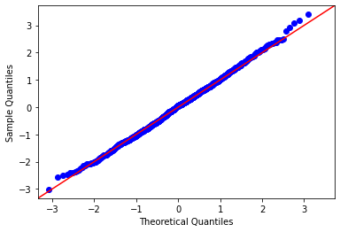

Fig 8. QQ plot of a normal distribution

In this research we use historical VaR to calculate it, so we can avoid the normality assumption. For the portfolio historical VaR we need to calculate the covariance matrix between our stocks and find the average return of the portfolio and its standard deviation (as a weighted mean of stock averages and standard deviations). After that, we Calculate the inverse of the normal cumulative distribution (PPF) with a specified confidence interval, standard deviation, and mean and finally estimate the VaR by subtracting the initial investment from the calculation. For demonstration purposes, let’s say our initial investment was 100 000 (HRK,€,$, etc).

VaR_2019=804,47

VaR_2021=888,68

If we use VaR as the measure of risk, we can see that for the same confidence interval for different years, VaR increased. This is the beauty of multiple risk measures because everyone gives us a new perspective. As an investor, we should use as many measures as possible to evaluate the risk of an investment.

*Correlation and diversification*

I have already previously discussed diversification, but let’s get more into detail with it. Diversification works best when assets are uncorrelated or negatively correlated with one another so that as some parts of the portfolio fall, others rise [12]. Correlation represents the degree of relationship between the price movements of different assets included in the portfolio. A correlation of +1.0 means that prices move in tandem; a correlation of -1.0 means that prices move in opposite directions. A correlation of 0 means that the assets have no relationship, the movement of one asset doesn’t affect the movement of another one.

Of course, this is in theory. In practice, it is very difficult to find assets that have a perfect positive, negative or neutral correlation. But it is an important factor when choosing assets for a portfolio. Let’s say a correlation between multiple assets is very strong, and then comes a financial or a health crisis that causes the price of those assets to go down. That will result in huge losses for the portfolio holders. That is the reason why investors diversify their portfolios and take care of the correlation between assets. Taking that same case, if we for example have some assets in our portfolio that have a negative correlation, they will be able to compensate for our losses in that case. The question remains of the amount of compensation they are able to provide, but that is a question for another time.

To help us determine the relationship between assets we can use a correlation matrix. It is a tool used by investors and statisticians do determine the nature of the relationship between assets. Each pair of assets is assigned a number which quantifies the degree of their movements. When choosing a portfolio, it is recommended to choose from a variety of assets, with different correlations. This is especially important in hard economic times. Diversification may not provide a complete insurance against disaster, but it does to some degree.

Which brings us to our chosen portfolio of stocks. Even though the assets in this portfolio don’t seem to be connected at the first glance (what does Podravka, a food company have in common with Atlantska Plovidba, a shipping company). We don’t actually know that until we perform a correlation analysis and visually present it.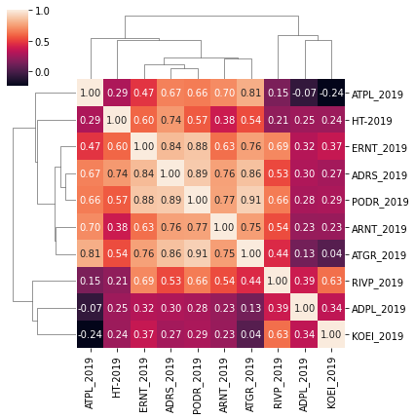

Fig 9. Heat map of the correlation matrix for the portfolio for 2019

For this heat map, the darker shades indicate lower correlation, while the lighter indicate stronger correlation. And the correlation between the two stocks is also presented in the picture in numerical form. On the diagonal, we have a perfect correlation, because in that case, we calculate the correlation between two identical assets.

As we can see in this map, companies from similar industries will have a stronger correlation coefficient. Let’s take for example Podravka (PODR) and Atlantic Group. Both companies are in the food business on some level (Podravka was always producing food, while Atlantic Group started as a distributor, but eventually turned to the food industry as well). The correlation between those two assets is really close to one, 0,91 to be exact. On the other hand, we have Končar (KOEI) and Atlantska Plovidba (ATPL). A producer of machines and a shipping company. Their correlation is very dark, meaning very close to 0., it is even negative (-0,24). Končar is trying to be innovative and improve its production, while Atlantska Plovidba is a distributor and a carrier.

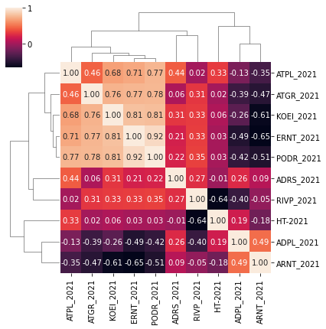

Fig 10. Heat map of the correlation matrix for the portfolio

for 2021

Let’s take a look for the correlation matrix for 2021,

and take the same companies that we took in the 2019 example to determine whether a change in correlation occurred. Podravka and the Atlantic group still have a strong

relationship, but not as strong as it was a year before (0,78). While the correlation coefficient between Končar and Atlantska plovidba has increased and now is positive (0,68). This only shows that the investors need to take care of the correlation of assets. Their correlation increased in that time period, which means that investors now need to take into consideration the movements of those assets more than they did previously. Previously, for example, if Končar’s price dropped, they didn’t need to concern themselves with the prices of Atlanstka plovidba, because had little to no relationship. But in 2021, they have a positive and stronger relationship, which means if the price of one asset is starting to go down, they need to take into consideration the

price of the other asset.

# Conclusion

Risk in the capital markets is a vital thing when deciding to invest. Even after quantifying it, it ultimately depends on the person investing, whether or not they think the risk is worth it. Risk prone people mostly will invest there where risk adverse people won’t. But things change in situations of global uncertainty. The pandemic certainly did that. It didn’t just initiate uncertainty, but also fear, which can make even the most risk-prone people adverse. As know when I have analyzed multiple approaches to risk, there only lies to answer the question, did and how did the risk on the Croatian capital market changed under the influence of the COVID-19 pandemic? The answer is unfortunately not that straightforward. The model of linear regression used to calculate the systematic risk implies that the risk decreased. This was an unexpected result. But, the Croatian capital market has been a specific case even before pandemic, being one of the few markets that didn’t fully recover even from the Financial crisis of 2008. This leads me to believe there were other factors that I had not taken into account when proposing initial expected results of the research. Nevertheless, the results are what they are and give us a whole new perspective when assessing risk. With the measure of the efficiency of the model being the mean squared error, and its value (presented earlier), it is on us to decide whether or not to trust this model and the conclusions we derived from it. The same can not be said for the standard deviation which slightly increased. On the other hand, we have the value at risk, which implies that the risk and the potential loss have increased as a result of the pandemic, which for some people might be the more logical outcome.

However, the final decision always lies with the investor and then depends only on how prone they are to take risks. But in every case, whether you are a high-stake broker or a recreational investor, you should take into account every measure available and then based on your personal preference, make a decision that you think you will have the most benefit from.

# references

1. WHO. Coronavirus disease 2019 (COVID-19) situation report – 119. Geneva: WHO; 2020. Dostupno na: https://www. who.int/docs/default-source/coronaviruse/situation-reports /20200518-covid-19-sitrep-119.pdf?sfvrsn=4bd9de25_4
2. Vince, A., 2020. COVID-19, five months late. *Liječnički vjesnik*, [online] Available at: <https://doi.org/10.26800/LV-142-3-4-11> [Accessed 17 May 2022].
3. Investopedia. 2022. *Portfolio*. [online] Available at: <https://www.investopedia.com/terms/p/portfolio.asp> [Accessed 20 May 2022].
4. Hayes, A., 2022. *Financial Risk: The Art of Assessing if a Company Is a Good Buy*. [online] Investopedia. Available at: <https://www.investopedia.com/terms/f/financialrisk.asp> [Accessed 20 May 2022].
5. Investopedia. 2022. *Diversification*. [online] Available at: <https://www.investopedia.com/terms/d/diversification.asp> [Accessed 17 May 2022].
6. Brealey, R., Myers, S. and Marcus, A., n.d. *Fundamentals of corporate finance*.
7. Capiński, M. and Zastawniak, T., 2011. *Mathematics for finance*. London: Springer.
8. En.wikipedia.org. 2022. *Interpolation - Wikipedia*. [online] Available at: <https://en.wikipedia.org/wiki/Interpolation> [Accessed 17 May 2022].
9. Wikipedia Contributors (2019). *Mean squared error*. [online] Wikipedia. Available at: <https://en.wikipedia.org/wiki/Mean_squared_error>.
10. Hull, John. *Risk Management and Financial Institutions*. Boston, Mass., Pearson Education, 2010.
11. Hayes, Adam. “Correlation.” *Investopedia*, 28 Mar. 2021, [www.investopedia.com/terms/c/correlation.asp](http://www.investopedia.com/terms/c/correlation.asp)
12. Singh, Manoj. “Protecting Portfolios Using Correlation Diversification.” *Investopedia*, 2019, [www.investopedia.com/articles/financial-theory/09/uncorrelated-assets-diversification.asp](http://www.investopedia.com/articles/financial-theory/09/uncorrelated-assets-diversification.asp)

‌